1. Explain Abstract Data Type?
2. What is skip list? Write about open addressing technique?
3. What are the different rotations in splay tree?
4. Define Fibonacci Heaps.
5. What is augmenting path ?
6. Explain the search and update operations performed on skip lists?
7. What are 2-3 trees how it works with data structures discuss with an example?
8. Describe The Knuth-Morris-Pattern Algorithm?
9. Discuss the working of Brute force pattern matching?
10. Write about The Boyer-Moore Algorithm?
11. How Compressed Tries work explain its operations.
12. Explain Standard Tries with an example?
13. What is Priority Range Trees discuss with an example?
14. Describe Quad trees and its functions?
15. Explain k-D Trees with an example?
16. What is computational geometry?
17. Briefly explain LUP decomposition.
18. Explain Ford-Fulkerson Method to compute maximum flow of the below flow network.

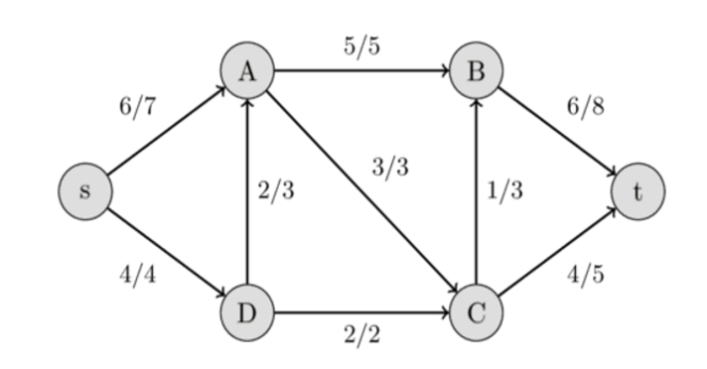

1. a) Explain the Huffman coding algorithm. What is the prefix rule and applications of it.

b) Construct the Huffman tree for the string str = "abbcdbccdaabbeeebeab"  .

1. a) What is 2-3 tree ? Discuss the various cases of inserting a node into a 2-3 tree.

b) What is splay tree ? How it is different from AVL and Red-Black trees?

c) Write the steps involved to search element 9 from the below splay tree.

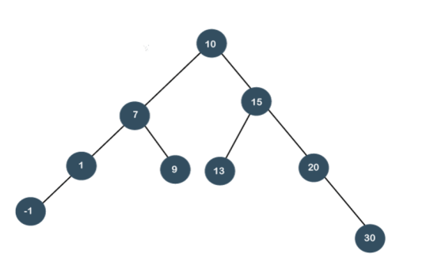

4. a)What is a B-Tree. Specify its properties and describe the construction of a B-Tree for the following elements 5, 2, 13, 3, 45, 72, 4, 6, 9, 22.

b) Define Tires and discuss the function Suffix Tries with an example?

5. a) Explain Skip List. Why it is called as a Randomized Data structure.

b) Explain the Operations Insertion, Deletion and Searching with a Skip List.

6. a) Explain Red black trees with an example?

b) How Two Dimensional Range Searching done in computational geometry explain with an example?

7. a) Discuss Strassen’s matrix multiplication algorithm, write its recurrence equation and find its time complexity. Compute the lower bound time complexity of matrix multiplication algorithm in big omega ‘Ω’ notation.

b) How Red-Black Tree is different from AVL Tree? Write their properties and give examples. Construct a R-B Tree with elements {10, 15, 18, 21, 27, 29}. If we insert an element 25, what new changes will it face?

8. a) Explain One Dimensional Range Searching with an example?

b) Solve the following linear programming problem by simplex method.

